OTHER CERTIFICATES AND ACHIEVEMENTS
~ARYA.A
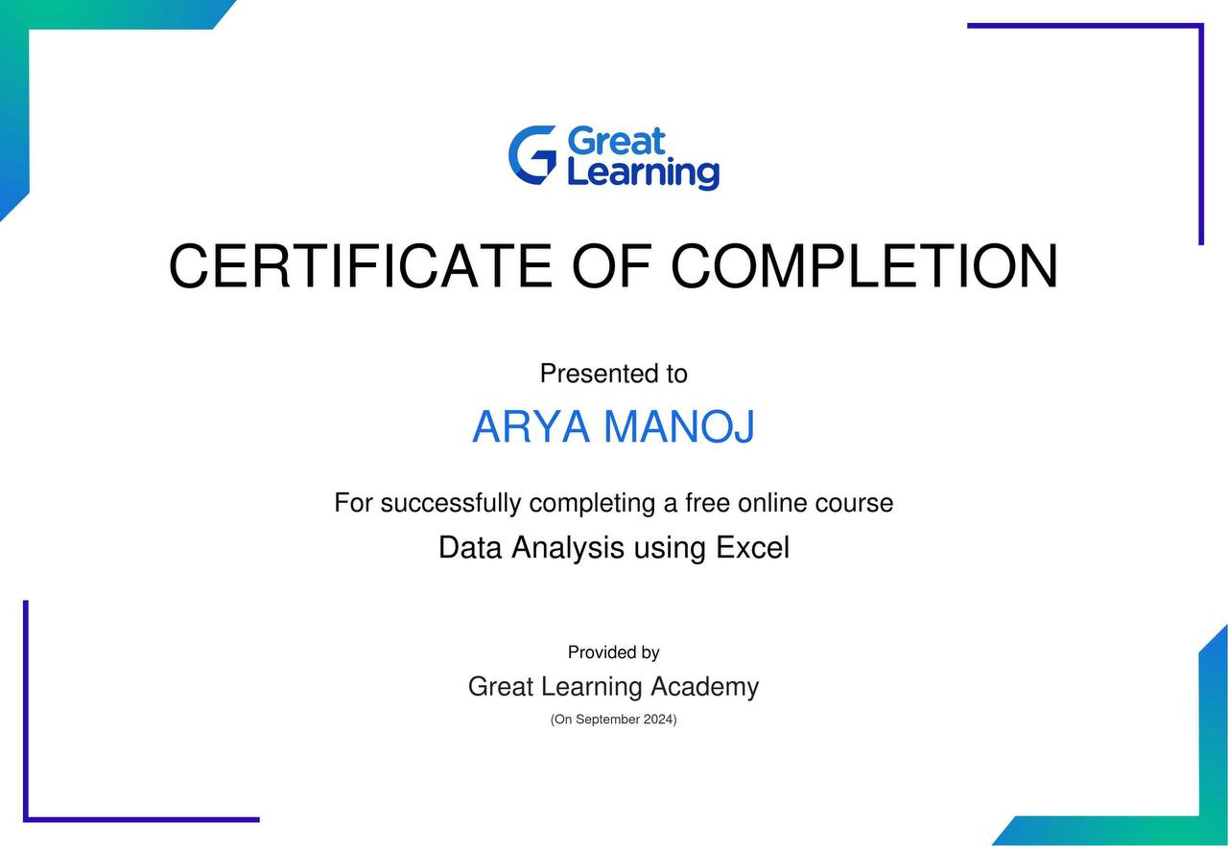

GREAT LEARNING DATA ANALYSIS USING EXCEL
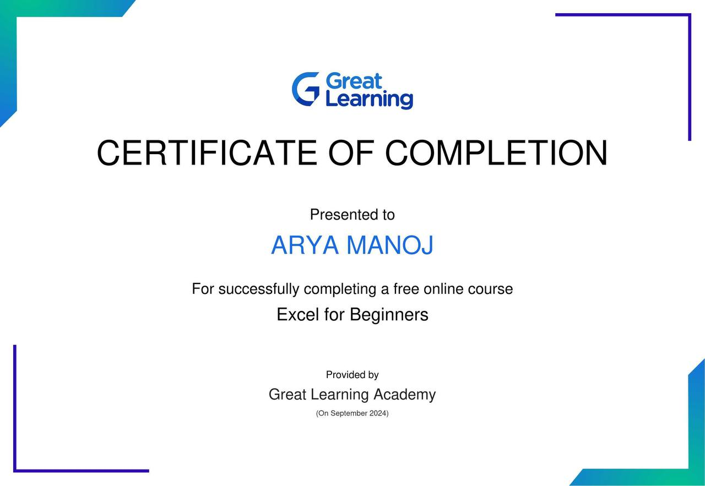

GREAT LEARNING EXCEL FOR BEGINNERS
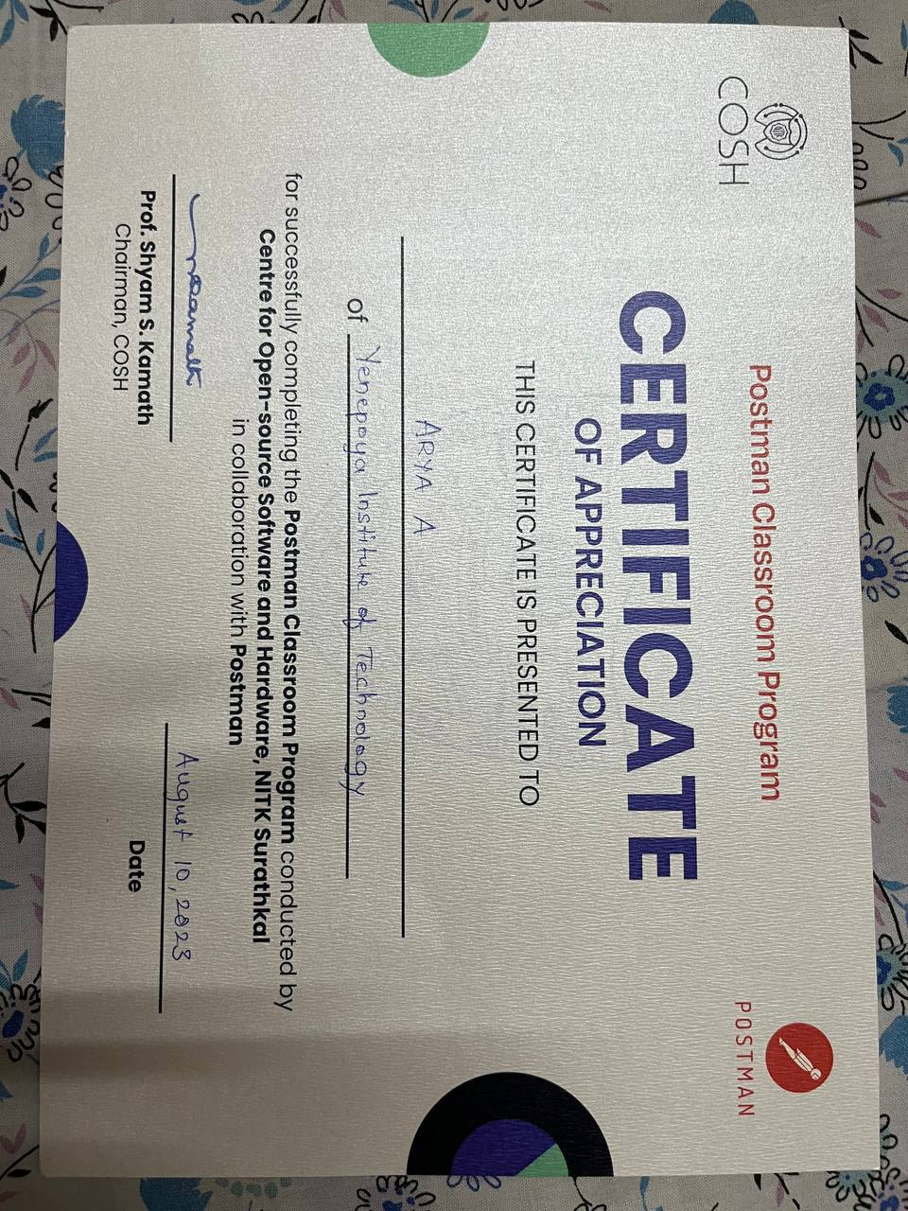

POSTMAN STUDENT EXPERT CLASSROOM PROGRAM

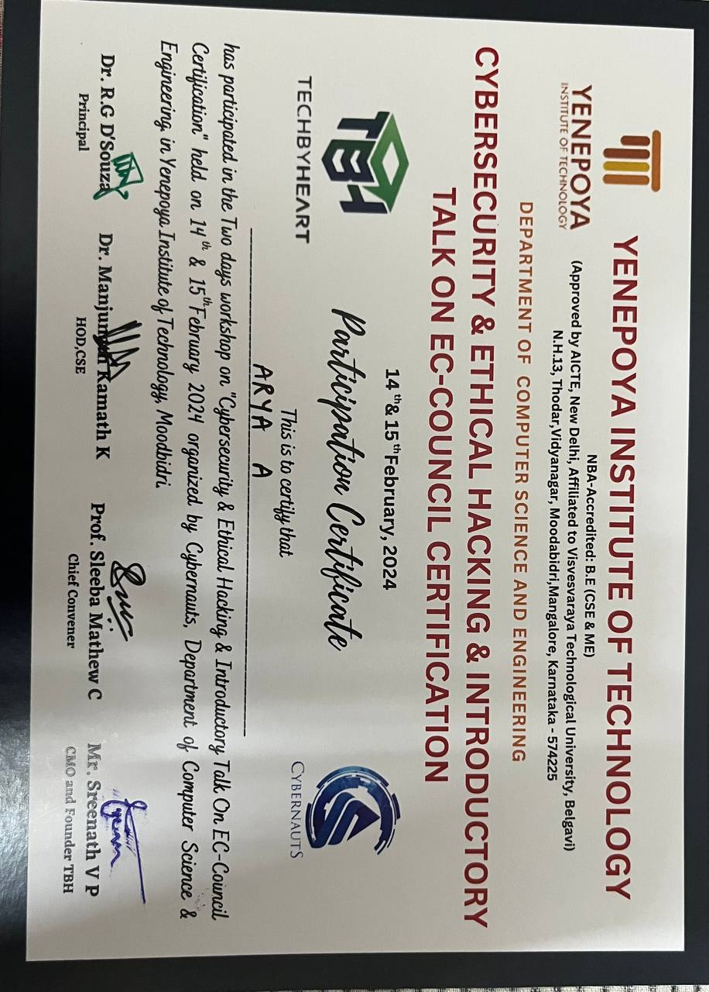WORKSHOP ON CYBERSECURITY AND ETHICAL HACKING

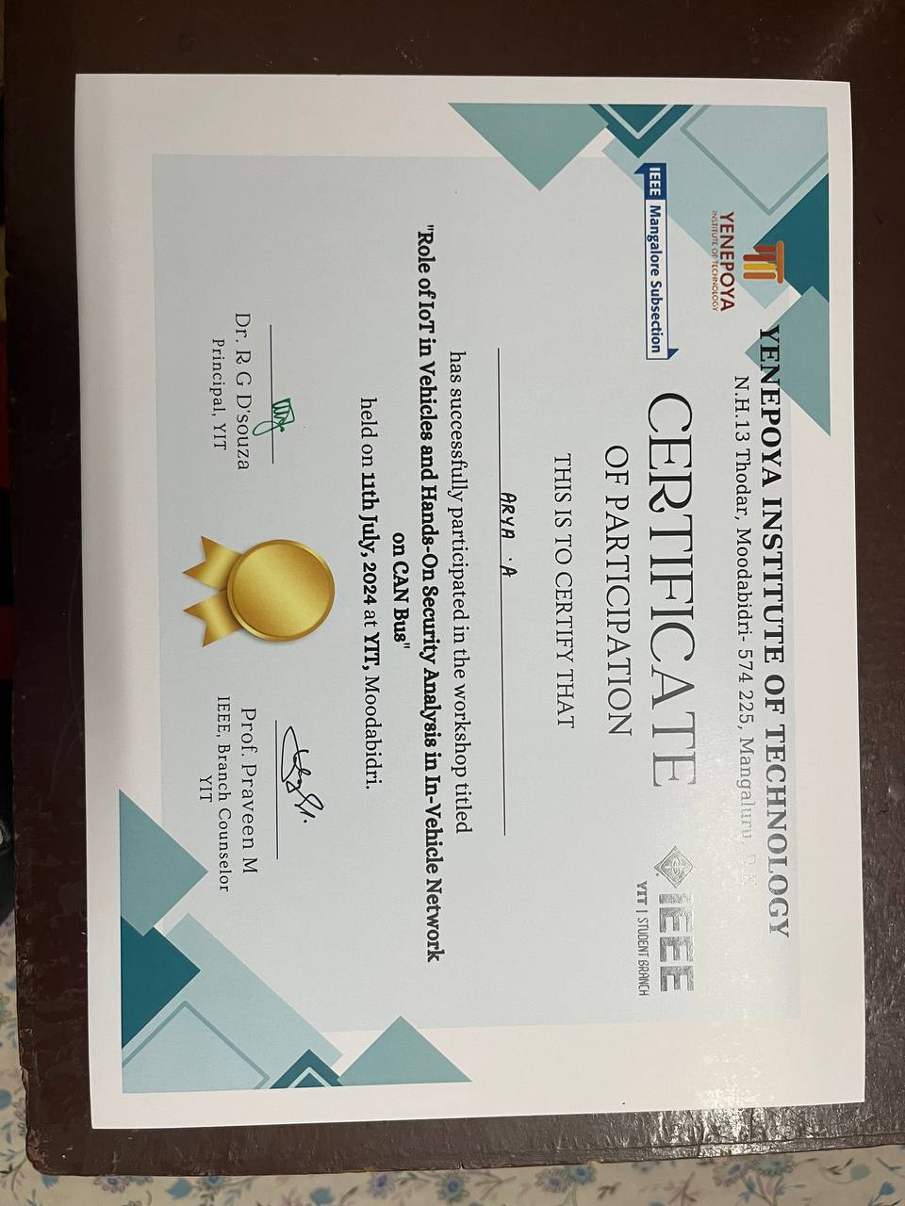WORKSHOP ON ROLE OF IOT IN VEHICLES AND HANDS ON SECURITY ANALYSIS IN IN-VECHICLE NETWORK ON CAN BUS
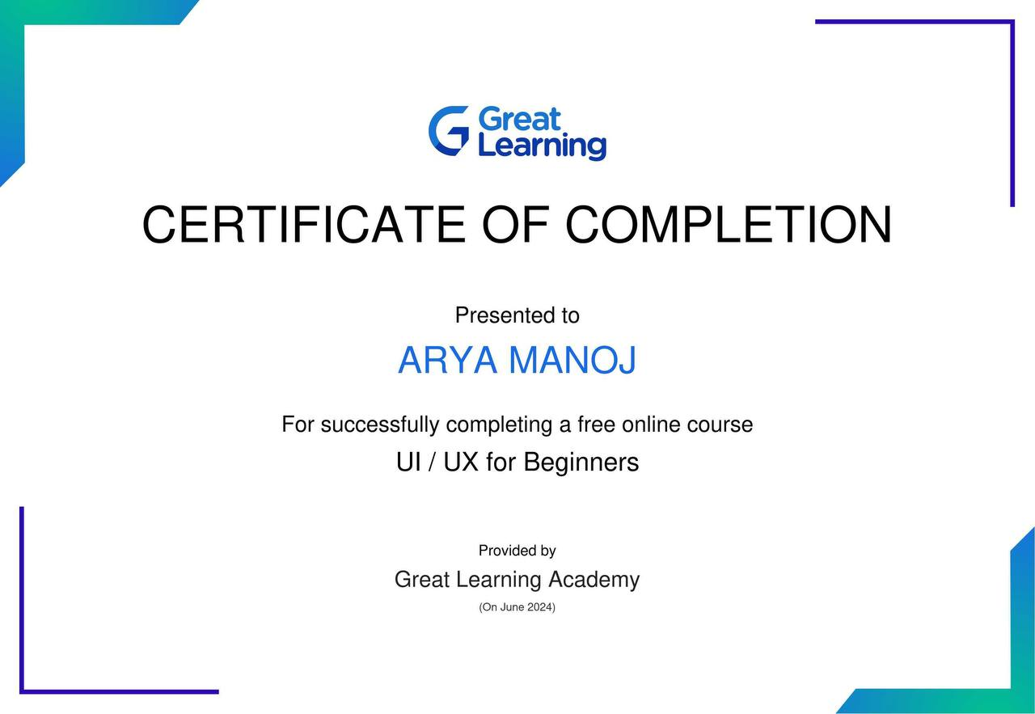
GREAT LEARNING UI/UX FOR BEGINNERS
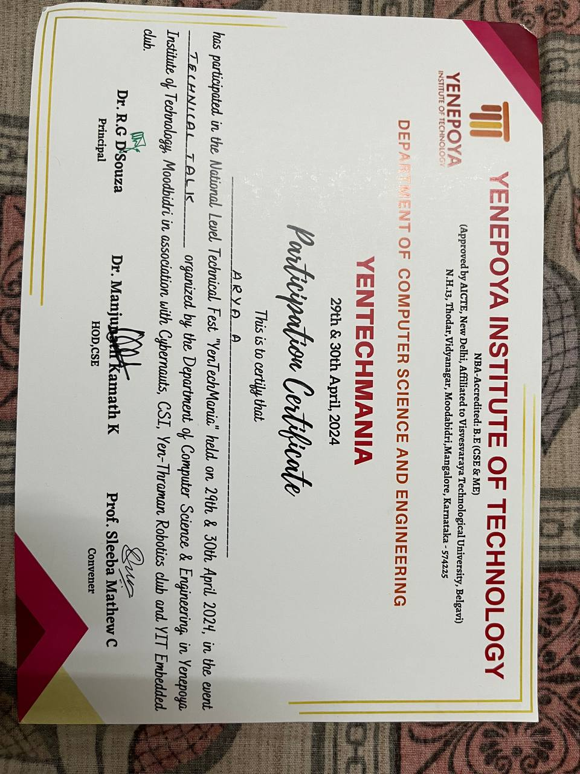

YENTECHMANIA TECHNICAL TALK PARTICIPATION

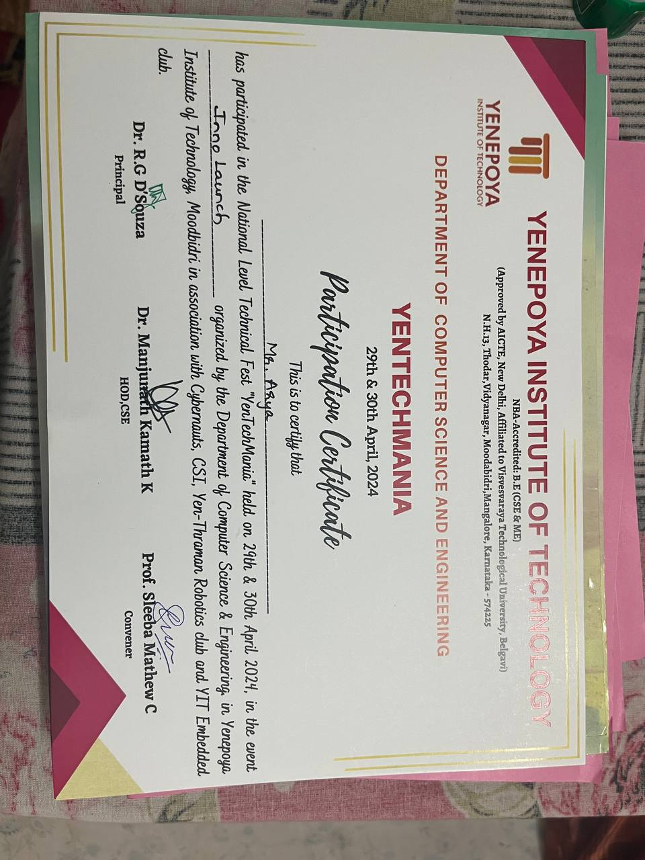
YENTECHMANIA NATIONAL LEVEL FEST INNOLAUNCH PARTICIPATION
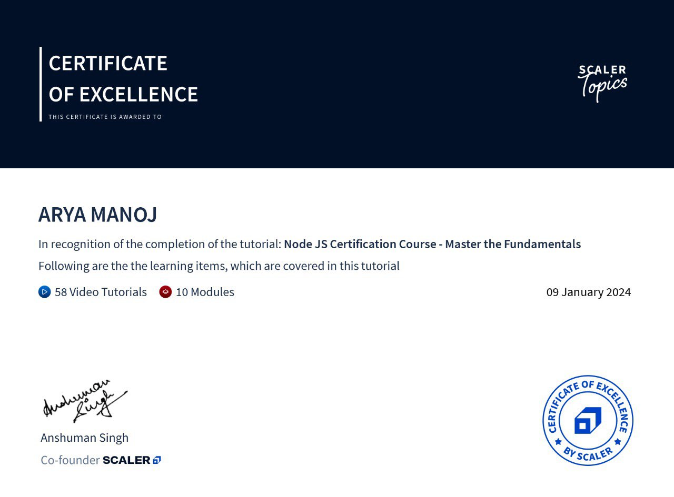
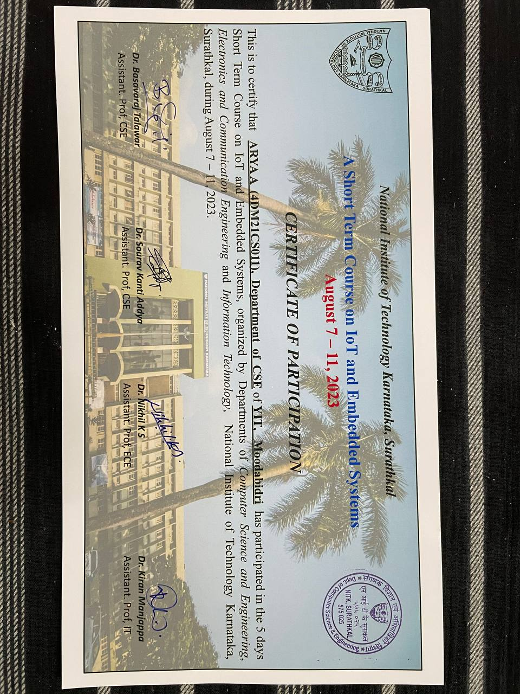

WORKSHOP ON IOT AND EMBEDDED SYSTEMS
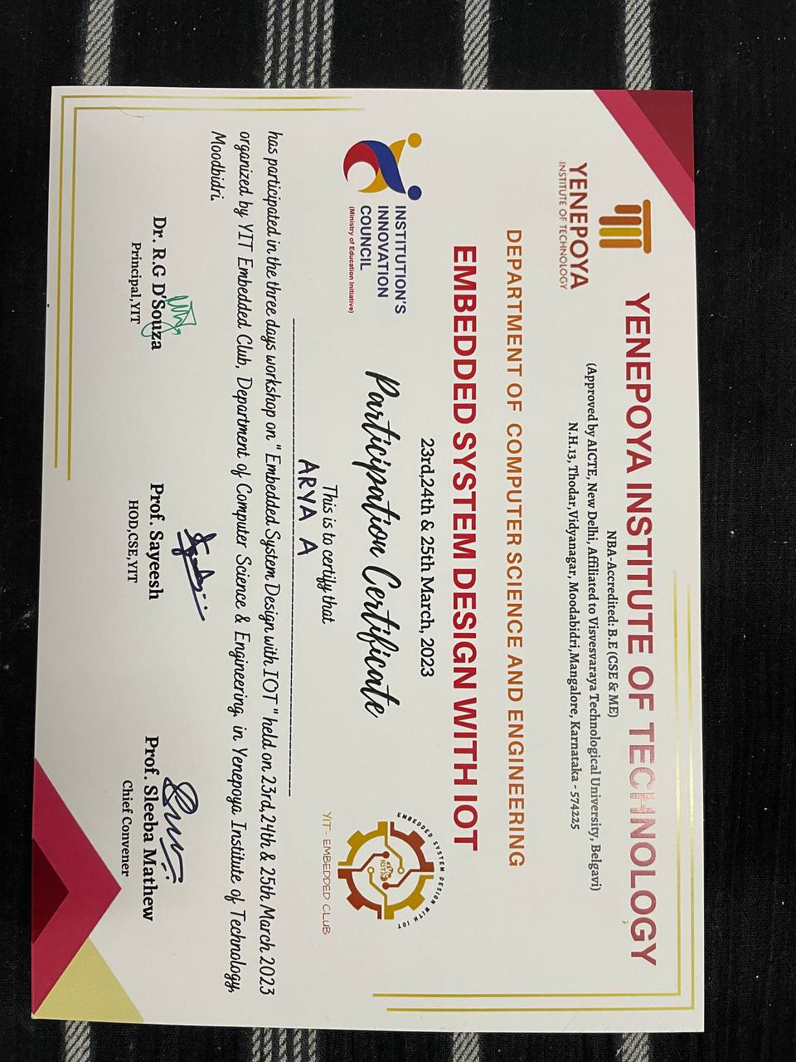 WORKSHOP ON EMBEDDED SYSTEMS WITH IOT
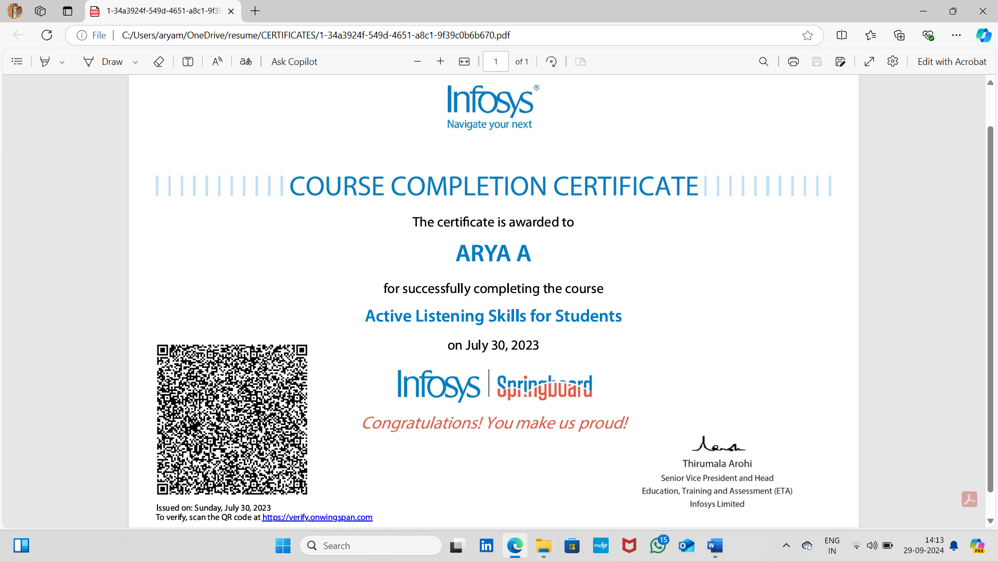

ACTIVE LISTENING SKILLS FOR STUDENTS,INFOSYS
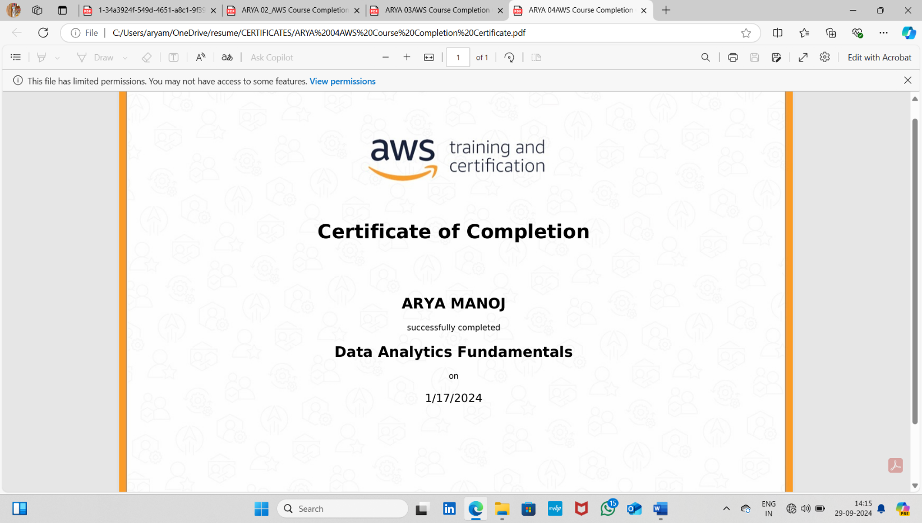

DATA ANALYTICS FUNDAMENTALS,AWS

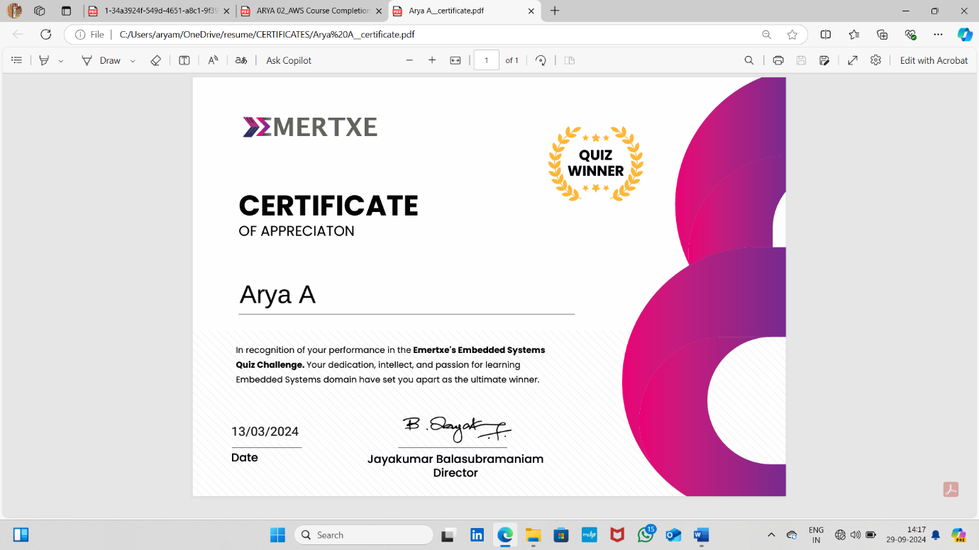

EMERTEX’S EMBEDDED SYSTEMS QUIZ WINNER

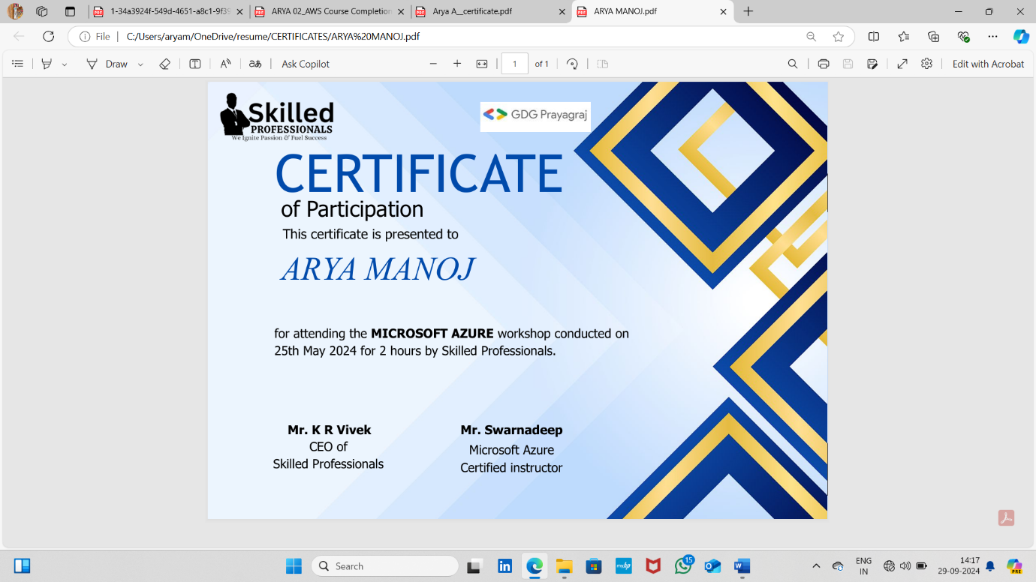
MICROSOFT AZURE WORKSHOP

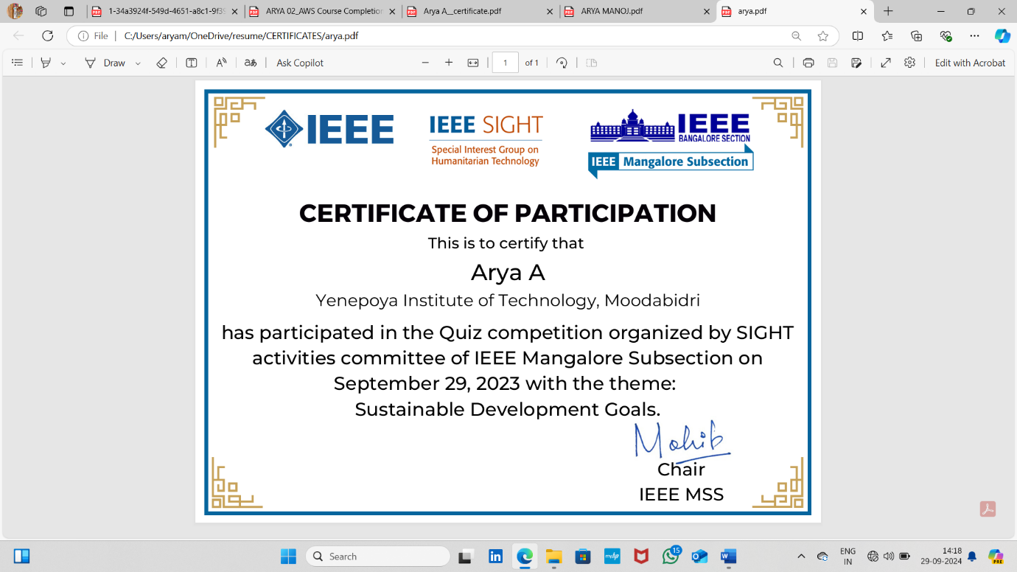

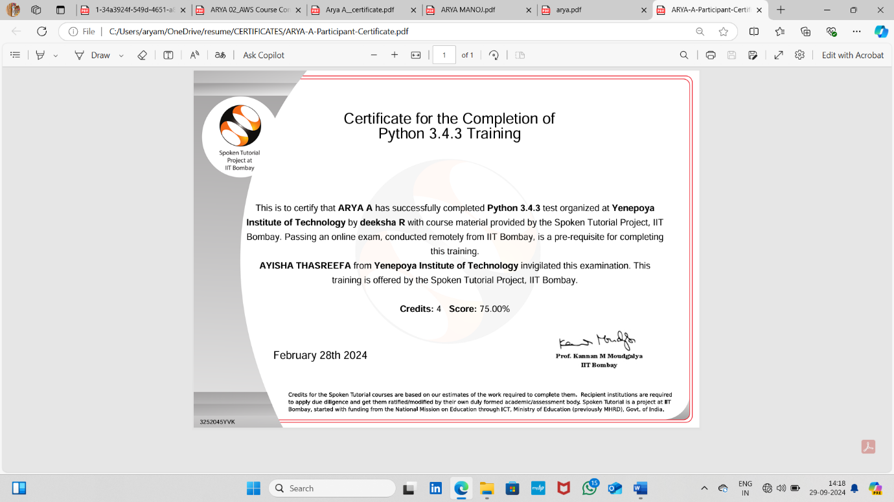
IITB BOMBAY PYTHON TEST

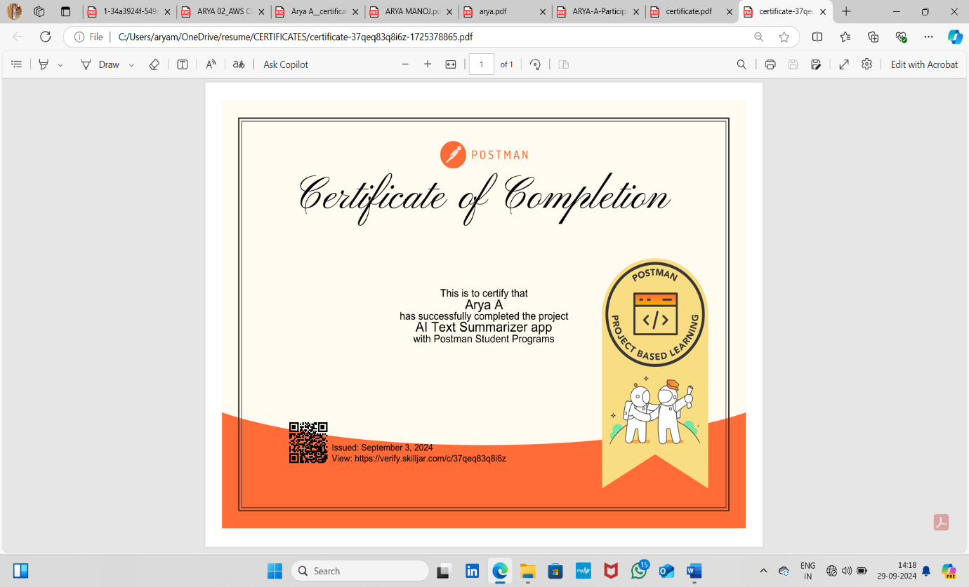

PROJECT BASED LEARNING AI-TEXT SUMMARIZER APP ,POSTMAN

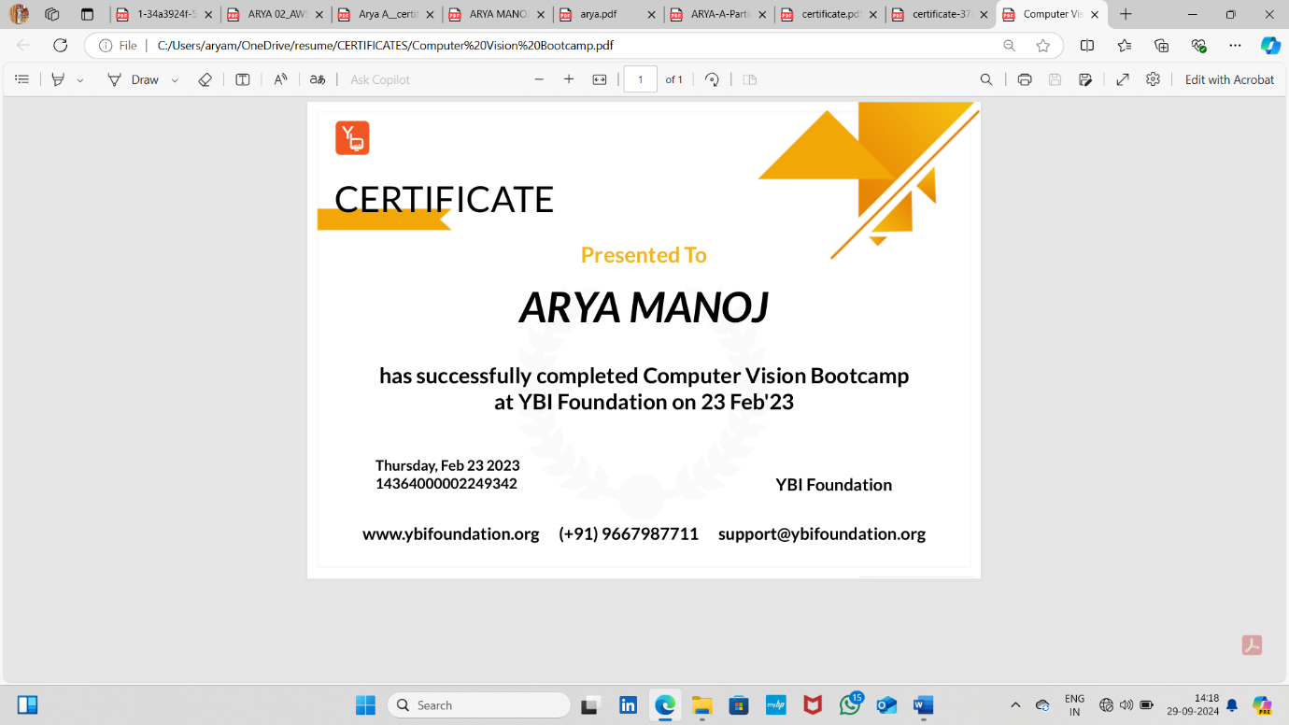
COMPUTER VISION BOOTCAMP AT YBI FOUNDATION
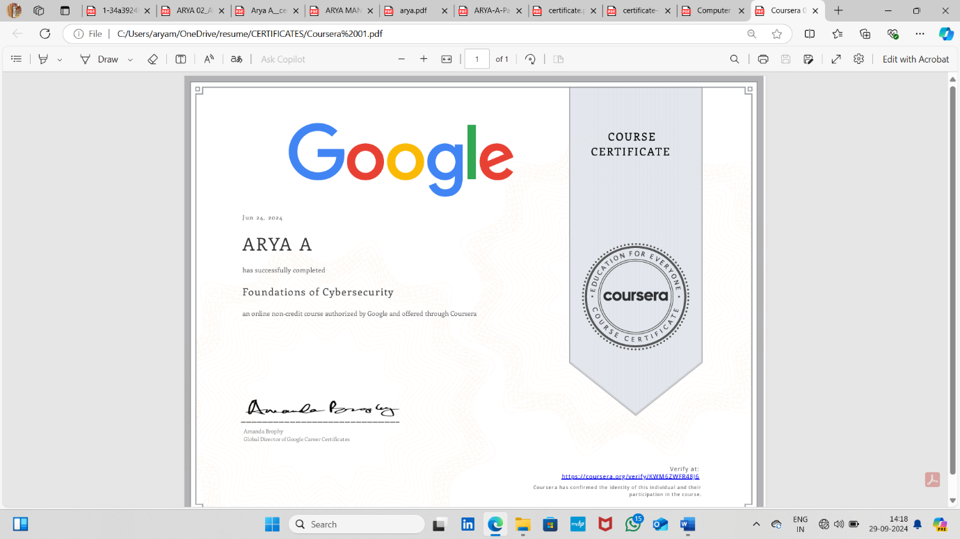
GOOGLE FOUNDATION OF CYBERSECURITY

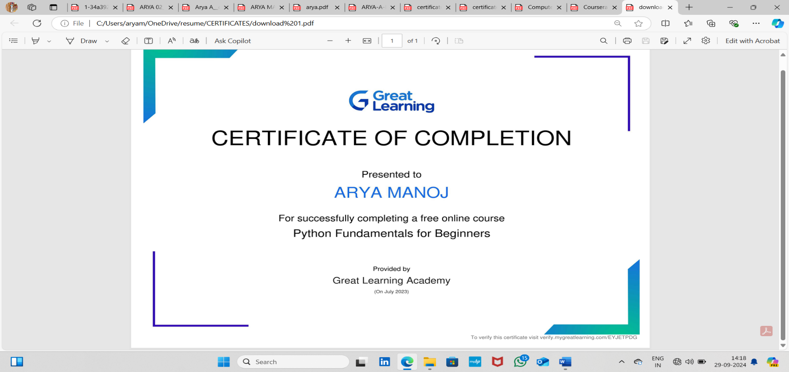

GREAT LEARNING PYTHON FUNDAMENTALS FOR BEGINNERS

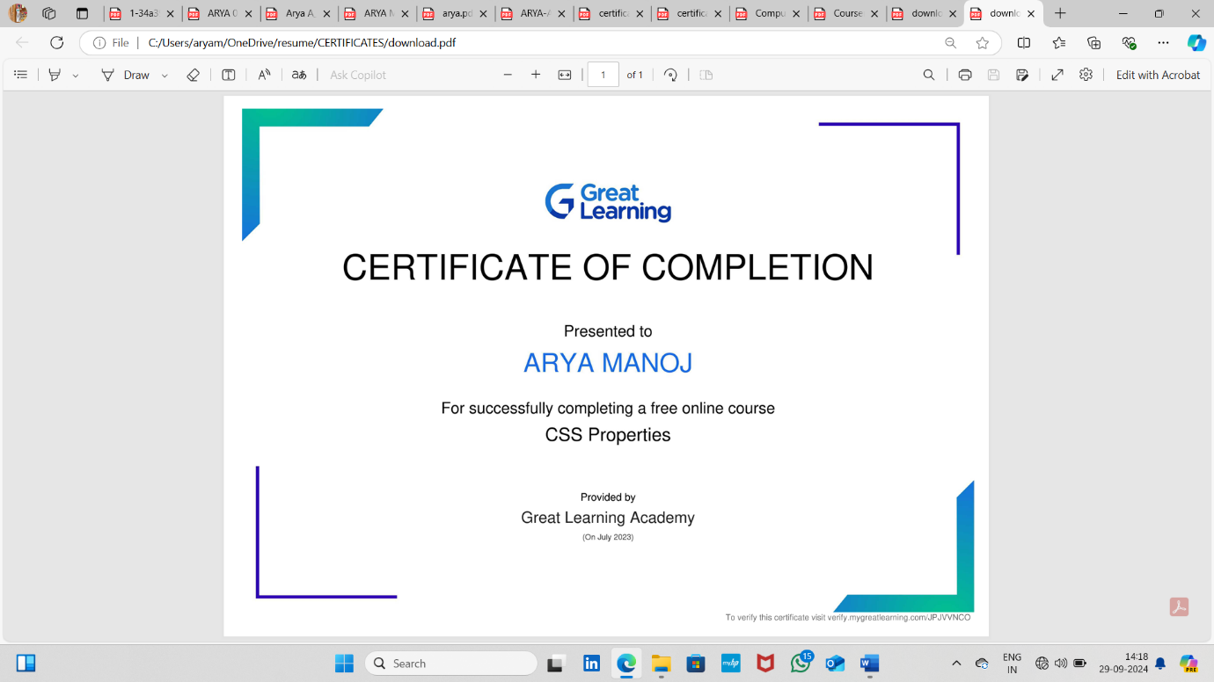
GREAT LEARNING CSS PROPERTIES

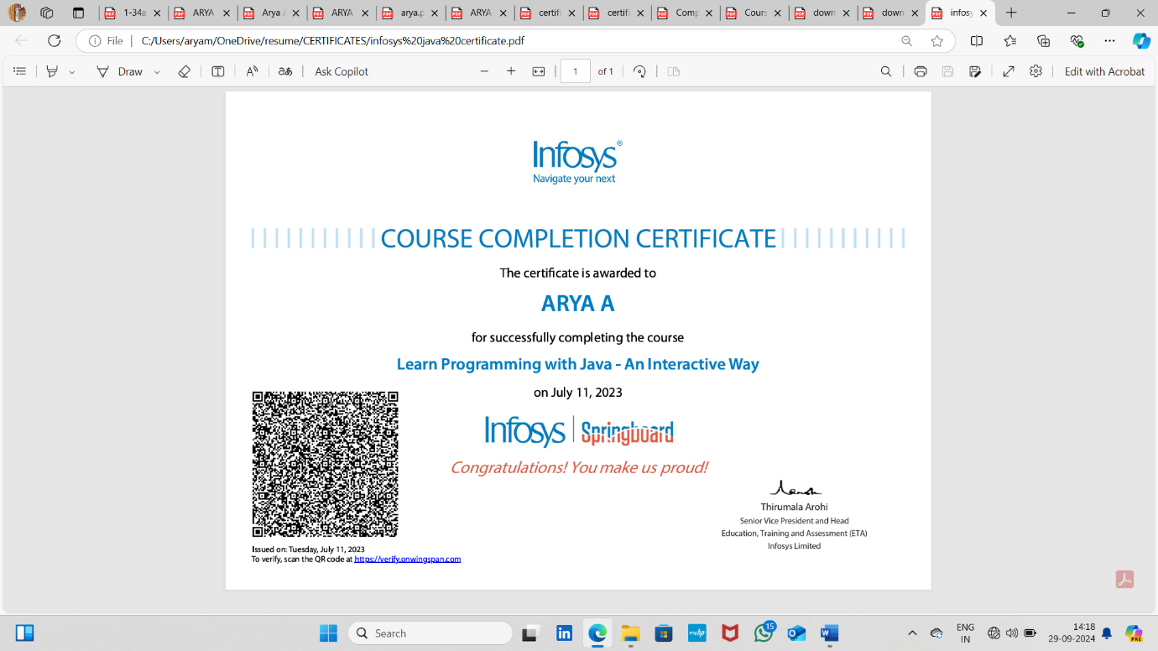

LEARN PROGRAMMING WITH JAVA ,INFOSYS

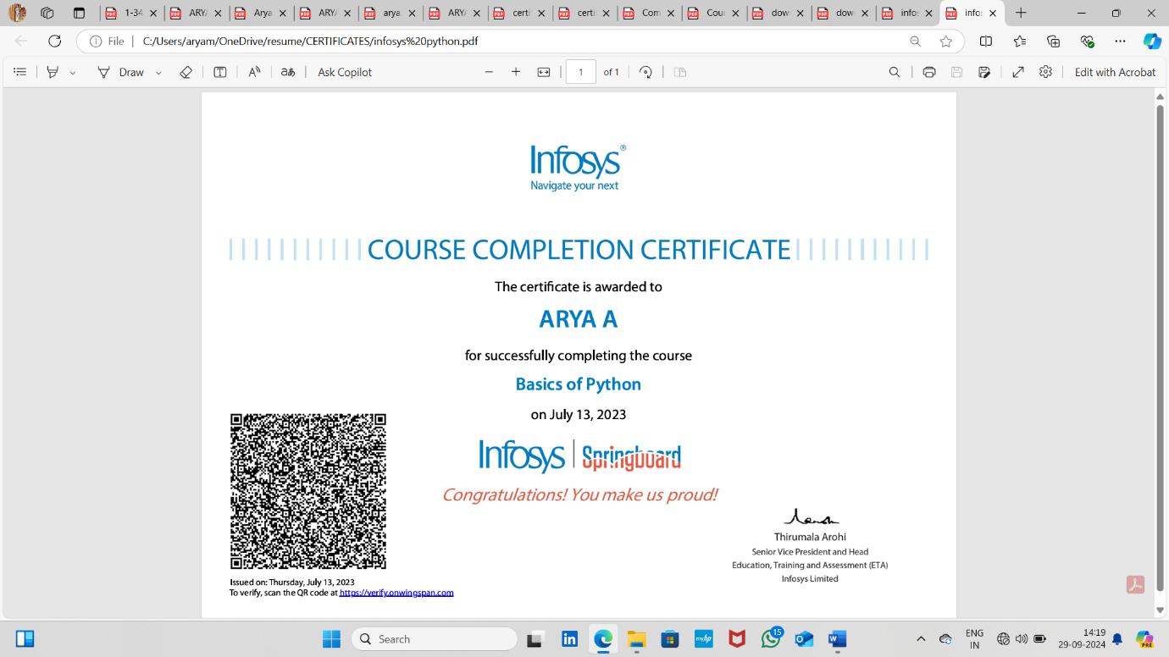

BASICS OF PYTHON,INFOSYS

